Muhammad Hashir Ashraf

2026-MS-AI-26

Cupcake Dataset: Preprocessing and Binning

1. Data overview
The dataset contains 160 monthly rows with five columns: Month, MonthIndex, Cupcake (a 4–100 interest index), AdSpend and Orders. Orders is the target. AdSpend is the only column with missing values (8 of 160); all other columns are complete.
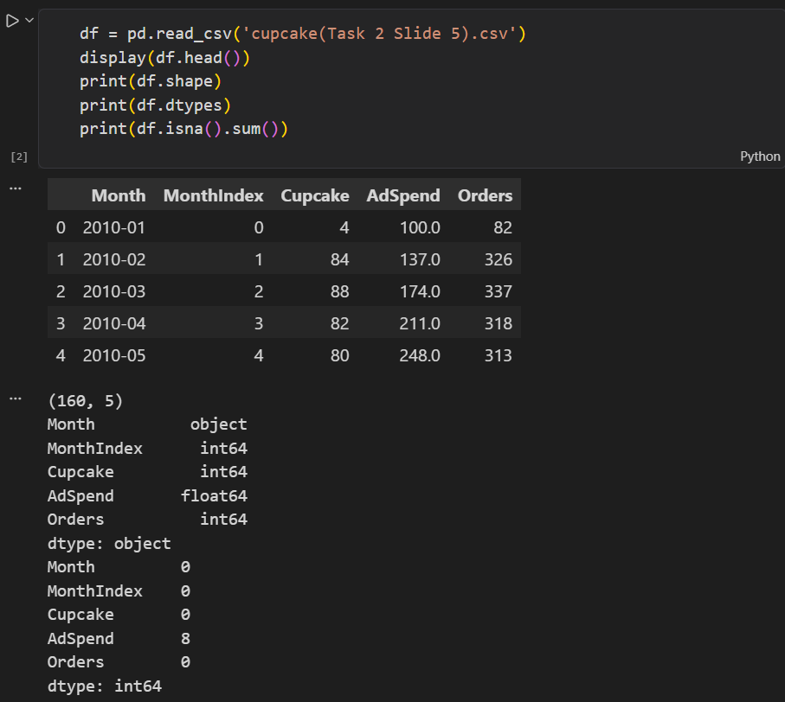

2. Train/test split
Cupcake and AdSpend were used as inputs. Because the data is a monthly time series, the last 20% of rows was held out for testing with shuffle=False, giving 128 training rows and 32 test rows. This keeps training data earlier than test data and avoids leaking future information.

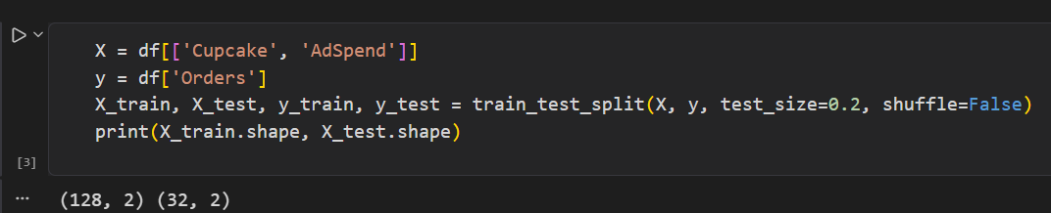

3. Median imputation
A median imputer was fitted on the training inputs only and then applied to both sets. The learned medians were Cupcake = 48 and AdSpend = 263. No missing values remain in either set. Fitting on training data alone prevents test information from influencing preprocessing.
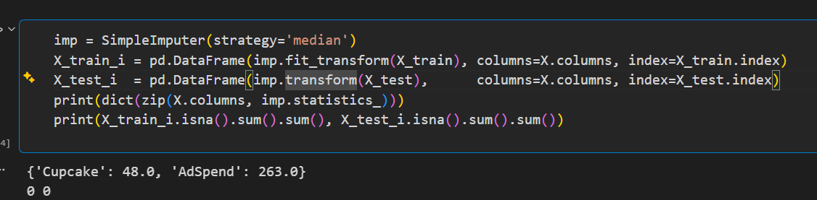

4. StandardScaler vs MinMaxScaler
Both scalers were fitted on the imputed training data only. The table shows the resulting ranges (Cupcake / AdSpend).
Scaler | Train range | Test range | Train mean
StandardScaler | −1.93 to 1.89 / −1.71 to 1.84 | −1.89 to 2.24 / −1.67 to 1.73 | 0 / 0
MinMaxScaler | 0 to 1 / 0 to 1 | 0.01 to 1.09 / 0.01 to 0.97 | 0.51 / 0.48

- StandardScaler centres each feature at mean 0 with standard deviation about 1. It has no fixed bounds and is less distorted by extreme values.
- MinMaxScaler maps training data into exactly [0, 1]. It is bounded but sensitive to outliers, and test values can fall outside [0, 1] (here up to 1.09) because the min and max come from training data.
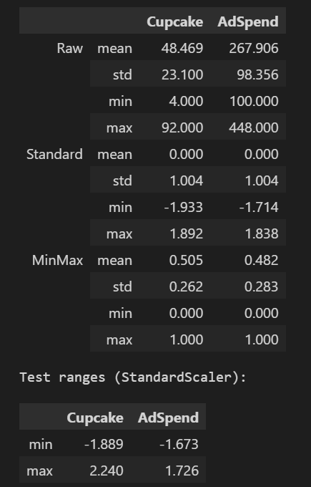
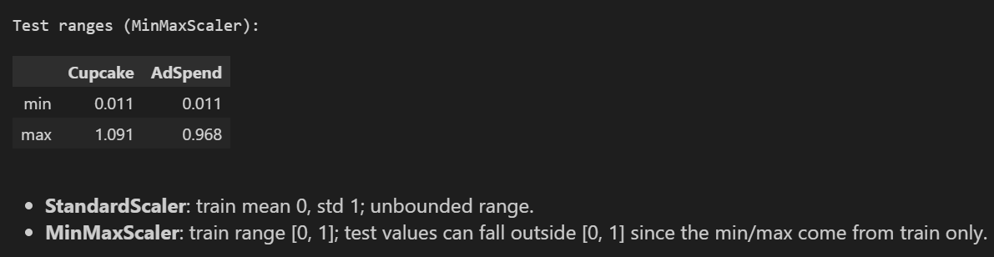

5. Binning Cupcake: cut vs qcut
Using the full CSV, Cupcake was split into three bins (Low, Medium, High) with each method.
Method | Edges | Low / Medium / High | Bin widths
pd.cut | 36, 68 | 53 / 69 / 38 | Equal (~32)
pd.qcut | 37, 60 | 56 / 51 / 53 | Unequal (33 / 23 / 40)
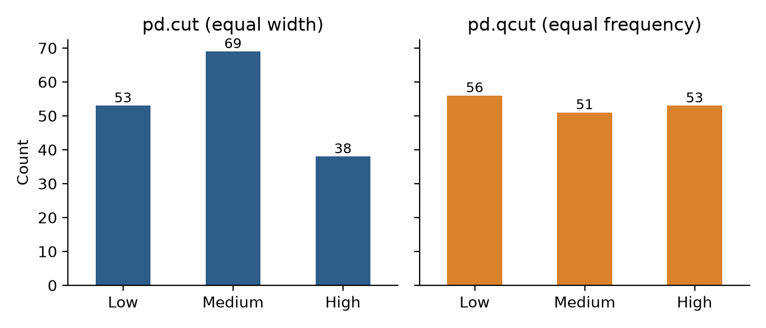
Figure 1. Bin counts for pd.cut and pd.qcut.
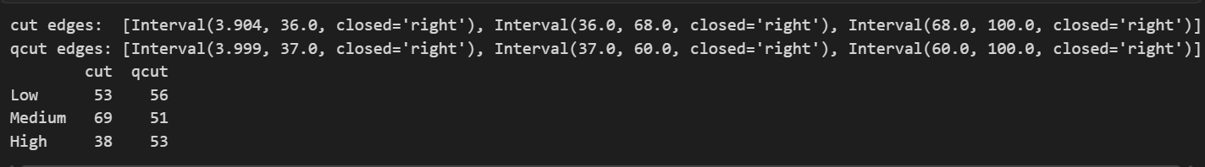

6. How the two methods differ
- cut divides the value range into equal-width intervals. Counts depend on the data distribution, so bins can be very uneven (69 vs 38 here), and skew or outliers can leave bins nearly empty.
- qcut places edges at quantiles, so each bin holds roughly the same number of rows (51–56 here) but the intervals have unequal widths. Counts are not exactly equal because Cupcake has tied values.
- Use cut when the interval boundaries themselves matter; use qcut when balanced groups matter.

